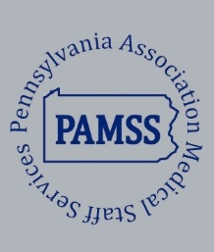
MEDICAL STAFF SERVICES ASSOCIATION OF PENNSYLVANIA

An Organization for the Medical Staff Services Professional
https://paamss.org

Membership Year – January 1, 2025 - December 31, 2025

Membership Fee - $70.00

Visit our website for more information and credit card payments or mail a completed application and check made payable to:

“Medical Staff Services Association of PA”

c/o Katie Sloat, PAMSS President-Elect

1659 S Geyers Church Road Middletown, PA 17057

Last Name |  |  | First |  |  |  | Middle

Current Job Title
Name of Facility |  |  | Type of Facility
 |  |  | Hospital  Managed Care |  |  | Other: _______________ ________________________
Street Address |  |  | City |  |  |  | State and Zip Code
Work Phone # | Cell Phone # |  | Email Address
Are you Certified? | Yes  No | Type of Certification: CPMSM CPCS Other(s):
If not CPCS or CPMSM certified, are you interested in becoming certified? Yes No  Which certification? CPMSM CPCS |  |  |  | Would you be willing to pay an additional fee for the PAMSS Annual Education Conference (for the cost of training manuals and supplies) if a NAMSS sponsored prep course was offered as a breakout session?  Yes No
Are you a member of your local chapter? |  |  | Yes No |  | Northwestern Southwestern  South Central Southeastern
Would you like more information regarding your local chapter? |  |  |  |  | Yes No
Are you a member of NAMSS? |  |  |  |  | Yes No
Would you consider participating in PAMSS Committee work? |  |  |  |  | Yes No
Are you a NEW MEMBER? |  |  |  |  | Yes No

__________________________ ________________________
Signature Date

